**AN ONLINE BUILDING MATERIALS ORDERING SYSTEM FOR ALFA BELLO COMPANY**

**ABSTRACT**

*The magical impact of computer has made enormous contribution to all aspect of the society people can now do things easily unlike in the past. Computers have reduced human effort in their day to day life, by reducing both human labour and time in solving their problem which are both numerous / unlimited. The manual method used in Alfa Company for monitoring the record of buying, customers information and transaction was critically examined which leads to the design of an online building materials ordering and delivery system which will allow customers to book online and get it delivered almost immediately after payment has been made. The proposed system also allows customers to make payment online, which ease the stress of going to the bank. The website will be design using PHP and MySQL. This language was chosen because of it wealth of class libraries and features for developing and online based application.*

**CHAPTER ONE**

**INTRODUCTION**

1. **Preamble**

This chapter gives an overall [review](https://explorable.com/what-is-a-literature-review) of the project, it show details of what the project is all about and how it will be implemented. It works upon the principle of introducing the topic of research and setting it into a broad context, gradually narrowing down to a [research problem](https://explorable.com/defining-a-research-problem). This chapter involves the introduction to this project expressly the background of the study, motivation, scope of the problem, purpose of the study, methodology and expected contribution to knowledge.

**1.1 Background of the Study**

The world of retail is undergoing an unprecedented wave of innovation. Technology, of course, plays a major role, but it is not the only force at work. New business modes are appearing that will have a profound influence a cross the e-commerce and wider retail value chain. At the same time, consumer behaviors and expectations are evolving.

Dean (2018), the role of IT is becoming more prominent in people’s daily lives and we are becoming increasingly dependent on computers. More and more business transactions are being automated, for example, ordering a goods online store or transferring money to a bank account in another part of the world when buying a good. No matter the type of transaction, we want it to be accurate and we want to have no doubts about its outcome.

However, in today’s world, where almost everything we do is backed up with computer automation, nearly all of these business transactions drive one or more corresponding activities in the information system. When you buy goods, the cashier enters the amount in the register, rings up a total, and collects your money. That activity might send a number of requests to an information system: to take those goods out of the sales database, approve your credit card exchange, update the store ledger, capture your store-loyalty status, and credit the store clerk with the sale. Each of these activities can be thought of as an IT transaction. Or, all of them together can be thought as a transaction. Or, some of these activities might be divided into smaller transactions. It all depends on how the application is written (Paul, 2018).

According to Hamdan (2017), what is clear is that the integrity of the business relies heavily on the integrity of these transactions in the information system. If any one of these activities fails to do its job correctly, the business will be out of balance. If the transaction database is not updated correctly, the store will think it has more goods on hand than it does. What happened to the goods? Did it get misplaced? Did someone steal it? Was it mislabeled? Likewise, if the credit card is not debited properly, the store could be out of money. If the loyalty status is not updated correctly, the customer will miss out on the rewards they deserve. If the ledger is not updated, the cash register will be out of balance at closing.

The sales rep registers detailed information of customer which is likely to bring about unending queue at the point of sales and repeated complaints about operational speed from the customers and security of information. This may also lead to wastage of storage space as information that may never be used again are collected from the customer and stored in the database while in the new system sales invoice generation module which involves the collection of information as brief as name and phone number of customer that is to be printed on the transaction invoice (Bolus Girder, 2017).

Traditional commerce: are face-to-face, telephone lines, or mail systems which make to call the system as manual processing of traditional business transactions because individual involved in all stages of business transactions

**1.2 Motivation**

The factors that influences the course of development of this work is that customers problem encounter when they want to purchase building materials, customer have to be at the company to make request for materials, some even go with a lot of cash to purchase building materials which is very dangerous and risky, all this problem motivate me to embark on this project work in order to eradicate the above problems mentioned. Also, organization and its accomplishment is good to be embraced so as to ensure that adequate majors are taken to booking of building materials, till now most organization still run a traditional method of buying of building materials system, The introduction of computer in construction company can have a positive or negative response to the society. Thus, it is necessary for the construction company to introduce an information system that would be used for the recording of event regarding and complication related to building materials booking.

However, precaution, principles and strategies should be undergone before innovating a computer system in the company, so that the effect can be treated. Certain factors should be considered before innovation of the computerized system will take shape. Other problem includes:

1. Difficulties in establishing and maintaining standard practices,
2. Communication/transactions are done in synchronous way manual intervention is required for each communication or transaction
3. No uniform platform for information sharing, as it depends heavily on personal communication.
   1. **Purpose of the Study**

The purpose of this study is to Design and Implement an online Building Materials Booking and Management Information System. Other purpose includes:

1. To provide a system that will efficiently meet customers’ demands and ensure proper financial accountability of the market price.
2. To design a system that will be used for obtaining building materials transaction report.
3. To evaluate the system developed.

**1.4 Methodology**

Methodology is the systematic, theoretical analysis of the methods applied to a field of study. It comprises the theoretical analysis of the body of methods and principles associated with a branch of knowledge. The research methodology used in this research work include the following; interview, the internet, textbooks and direct observation from people. These methods used provide reliable information of the required knowledge of this research and proper guidance; PHP will be employed as the front-end and MySQL as the back end for the design of the system.

**1.5 The Scope of Project**

This project is concerned with computerizing a building material sales, . and management information system but for obvious reason, our center of attraction is on building materials sales, . and management information system in the Company that will be done easily and effectively by the use of computer.

**1.6 Expected Contribution to Knowledge**

On completion of this project, students will have vast knowledge on database management system and how building materials records are been collected and stored on a database system.

Also, this project has expose student to have vast knowledge about domain, hosting and opens a window to the numerous opportunities Information Technology can offer in any given organization. However, failure to implement this system will lead to a great setback in the organization due to their unsecured method of record keeping. Other contributions include:

1. It exposes student to database management most especially MySQL.
2. It exposes student on hoe domain and hosting is been done.

**CHAPTER TWO**

**LITERATURE REVIEW**

**2.0 Preamble**

Literature Review entails to examine the critical points of past and current knowledge in a particular field of study. This is an objective, through summary and critical analysis of a relevant research available, which includes findings and contribution to the topic an online building material ordering.

2.1 Review of Related Literature

Building material is material used for construction. Many naturally occurring substances, such as clay, rocks, sand and wood, even twigs and leaves, have been used to construct buildings. Apart from naturally occurring materials, many man-made products are in use, some more and some less synthetic. The manufacturing of building materials is an established industry in many countries and the use of these materials is typically segmented into specific specialty trades, such as carpentry, insulation, plumbing, and roofing work. They provide the make-up of habitats and structures including homes (Haliru, 2018).

Manufacturing systems typically consist of multiple production stages, requiring multiple resources and producing multiple products. The stock can be defined as the quantification of items or tangible resources, moving or not, which are held by the organization in a given time interval (Souza & et al, 2019).

Hamadan (2018) Initial economic cost of building materials is the purchase price. This is often what governs decision making about what materials to use. Sometimes people take into consideration the energy savings or durability of the materials and see the value of paying a higher initial cost in return for a lower lifetime cost. For example, an asphalt shingle roof costs less than a metal roof to install, but the metal roof will last longer so the lifetime cost is less per year. Some materials may require more care than others, maintaining costs specific to some materials may also influence the final decision. Risks when considering lifetime cost of a material is if the building is damaged such as by fire or wind, or if the material is not as durable as advertised. The cost of materials should be taken into consideration to bear the risk to buy combustive materials to enlarge the lifetime. It is said that, "if it must be done, it must be done well. “In the commercial, the purchase and sale of goods are the most relevant operational activities that must have an appropriate level of inventory must be appropriate to serve customers at the right time, with the right amount required "(Koxne et al., 2016). Transactions that get executed by your applications when users interact with your services/web site. Knowing the accessed URL, its average response time and then mapping it to a Business Transaction is the simplest form of Business Transaction Management but doesn’t work in most cases because modern applications don’t pass the whole business transaction context in the URL. Modern applications are no longer monolithic. The challenge with that is that transactions are distributed, they take different paths, and data we need for our business context (username, product information, cash information,) is often available on different tiers. This requires us to trace every single transaction across all tiers in order to collect this data for a single user transaction:

Hamber (2020), a transaction processing system is composed of at least one transaction terminal which means that it can receive characteristic data from a user. Examples of which is an image of the user’s signature from data stored in a data processing system and the logic for producing a transaction message by combining transaction data with the characteristic data in such a way that the transaction data is required to get back the characteristic data from the message. A type of computer processing that is responding immediately to user requests is referred as the Transaction Processing System. Each of this request are considered to be called as transactions. One of the examples of this system is an automatic teller machine (Brown, 2019). However, (Mike, 2018), transaction Processing System has an opposite which is called a Batch Processing. In this type of processing system, a batch of user requests is stored and they can be executed all at one time. Interaction with user is required in a Transaction Processing while in a Batch Processing, it doesn’t mind if a user is present or not.

Laudon (2017), defines Information Systems as a set of interrelated components that collect (or retrieve), process, store, and distribute information to support decision making, coordination, and control in and organization. Information Systems (IS), can also be any organized combination of people, hardware, software, communications networks and data resources that stores and retrieves, transforms, and disseminates information in an organization (O‟Brien, 2017). In addition, IS are combination of hardware, software and telecommunication networks that people build and use to collect, create, and distribute useful data, typically in organization settings (Valacich & Schneider, 2018).

According to (Brien & Marakas, 2018), applications of information systems that are implemented in today’s business world can be classified in several different ways. They classify these as first, Operations Support Systems; which produce a variety of information products for internal and external use. This is to process data generated by, and used in, business operations. The role of this operation support systems is to efficiently process business transactions, control industrial processes, support enterprise communication and collaborations, and update corporate databases. The next classification is Management Support Systems, where IS an application focus on providing information and support for effective decision making by managers. Conceptually, several major types of information systems support a variety of decision-making responsibilities of Management Information System, Decision Support Systems and Executive Information System, thus, all systems that involve interaction with shared database can be considered to be transaction-based information system (Sommerville, 2018). An information system therefore allows controlled access to a large base of information. Increasingly, Information systems are web-based systems that are accesses through a web browser. (Valacich & Schneider, 2017).

**2.3** **Building Material**

Building materials are materials that are used in the construction of buildings, houses and other structures. This includes traditional materials such as wood and newer materials that are designed to meet a variety of modern construction requirements. The following are common types of building material.

1. Wood: A hard natural material that has been used for interiors and exteriors for thousands of years. Wood is a sustainable material when responsibly sourced as it is a carbon-neutral renewable resource.
2. Bamboo is a family of plants that is perceived as wood but is technically a grass. Bamboo is viewed as a sustainable material due to its high rate of growth with some species growing up to 1.5 inches an hour.
3. Concrete is a composite material that contains aggregates such as sand, gravel and crushed stone with a binder such as Portland cement. Chemical admixtures are often added to change the properties of the concrete or to speed up or slow down hardening.
4. Bricks are any rectangular units designed to be set in mortar. These are historically made of clay but modern bricks come in hundreds of varieties made from materials such as soil, sand, clay, lime, calcium-silicate, concrete and ceramics.
   * 1. **Benefits of online payments**

Online payment methods have several advantages which include the followings:

1. Convenience for online sales: Online payment methods allow conveniently selling goods and services online.
2. Automatic: Online payments can be automatic, which can be convenient for you and your customers.
3. Fast transaction speed: Online transactions quickly provide feedback to you and your customers.
   * 1. **Disadvantages of Online Payments**

Online payment methods have several disadvantages which includes the following:

1. Service fees: Payment gateways and third-party payment processors charge service fees.
2. Inconvenient for offline sales: Online payment methods are inconvenient for offline sales.
3. Vulnerability to cybercriminals: Cybercriminals can disable online payment methods or exploit them to steal people’s money or information. Visit the Australian Cybercrime Reporting Network’s Learn about cybercrime page to learn more about cybercrime.

**2.5 Electronic Record Keeping**

According to Albert (2019), most businesses use accounting software programs to simplify electronic record keeping, and produce meaningful reports. There are many other advantages to using electronic record keeping, as listed below.

**2.5.1 Pros of Electronic Record Keeping**

According to Stroh (2016), he stated the pros of electronic record keeping as follow:

1. Helps you record business transactions, including income and expenses.
2. Efficient way to keep financial records and requires less storage space.
3. Provides the option of recording a sale when you raise an invoice, not when you receive a cash payment from a client.
4. Easy to generate orders, invoices, debtor reports, financial statements, employee pay records, inventory reports.
5. Automatically tallies amounts and provides reporting functions. Keeps up with the latest tax rates, tax laws and rulings.
6. Many accounting programs have facilities to email invoices to clients, orders to suppliers, or BAS returns to the Australian Taxation Office.
7. Allows you to back up records and keep them in a safe place in case of fire or theft.

**2.5.2 Cons of Electronic Record Keeping**

According to Frankie (2015), he stated the cons of electronic record keeping as follow:

1. Expensive to set up.
2. Correcting entries may not be easier with electronic systems.
3. The risk of corrupted data is very high.
4. Data security
5. The process is not simplified as you need to be familiar with how accounting software calculates and treats your information.

**CHAPTER THREE**

**METHODOLOGY AND DESIGN**

**3.1 Introduction**

Research methodology is a careful study or investigation, especially in order to discover new fact or information, that is, the method used by the researcher to collect data or information; hence, research methodology should be sound enough to make attainment of the set objectives possible with specific components such as phases, tasks, methods. Techniques and tools can also be defined as the analysis of the principle of methods, rules and postulates employed by a discipline. This chapter entails the input and output specifications for the design online student project management system, Use case, Activity and Class diagrams as well as the system requirement.

**3.2 Method of Data Collection**

There are different methods of data collection, but the method of data collection used in this project work is interviewer and documentation method of data collection. In collecting the data, the following process was undergone: Outlined interview sessions and also consultation of various literatures and journals.

1. **Interview:** Interview method of collecting data is by asking the respondents direct questions face to face, this was first conducted with the project coordinator of the department of computer science and some graduating student of the department.
2. **Documentation:** Documentation method is a secondary method of data collection. This method involves the use of journals, handbooks, newspapers and projects. This method of data collection was used because it serves as a basis of reference to existing research work. This includes: Internet, Past Projects and text books.

**3.3 System Modeling using Unified Modeling Language (UML)**

System modeling is the interdisciplinary study of the use of models to conceptualize and construct system in IT development. A common type of system modeling is function modeling with specific techniques such as functional flow block diagram.

System Modeling can be done using several Modeling Language, but in this project work, we are using the Unified Modeling Language (UML). This is a general-purpose developmental modeling language in the field of software development that is intended to provide a standard way to visualize the design of a system.

### 3.3.1 Use Case Diagram

The purpose of Use Case Diagram is to present a graphical overview of the functionality provided by a system in terms of actors, their goals (represented as use cases), and any dependencies between those use cases.

Admin Customer

**Fig 3.3.1: System Use Case Diagram**

**3.3.2 Class Diagram**

Class diagrams are visual representations of the static structure and composition of a particular system using the conventions set by the Unified Modeling Language (UML). Out of all the UML diagrams types, it is one of the most used ones. System designers use class diagrams as a way of simplifying how objects in a system interact with each other. Using class diagrams, it is easier to describe all the classes, packages, and interfaces that constitute a system and how these components are interrelated.

PAYMENT

- CardName:String

- CardNumber:String

- Exp Date:String

- Cvv:String

+Submit():void

ADMIN

-UserName:String

-Password:String

+Login (): void

Customer Registration

-Customer id: int

-Full name: String

-Email: String

-Phone: String

-Shop Number: String

+Register (): void

Staff Registration

-staff id: int

-Full name: String

-Gender: String

-Email: String

-Phone: String

-Password: String

+Register (): void

***Figure: 3.3.2 Class Diagram***

**3.3.3 Activity Diagram**

Activity diagrams are graphical representations of data-flows of step wise activities and actions with support for choice, iteration and concurrency. In the Unified Modeling Language, activity diagrams are intended to model both computational and organizational processes (i.e.

workflows). Activity diagrams show the overall flow of control. Activity diagrams are constructed from a limited number of shapes, connected with arrows.

Open Database

Accept Login ID

Invalid?

Valid

Enter Staff Details

Exist

Proceed

Save

Close Database

**Fig 3.3: Add Staff Activity Diagram**

Open Database

Accept User ID

Invalid

Valid

Update Record

Close Database

**Fig 3.4: Edit/Update Staff Activity Diagram**

Open Database

Accept User ID

Valid

Confirm Deletion

Close Database

Delete Details

**Fig 3.5: Delete Staff Activity Diagram**

### 3.4 Database Design

### Database design is the organization of data according to a database model. The design determines what data must be stored and how the data elements interrelate.

### MySQL is used for the database of this project work. The most popular open source SQL database is provided by MySQL is a relational database that stores data in separate tables rather than putting all data in one big storeroom. This adds speed and flexibly. The tables are linked by denned relations making it possible to combine data from several tables on request. The SQL part of MYSQL stands for “structured Query Language”– the most common standardized language used to access databases.

### Input design in an information system, input design is the raw data that is processed to produce output. it should serve specific purpose effectively such as storing, recording and retrieving the information. It ensures proper completion with accuracy. it should be easy to fill and straight forward.

**Table 3.1:** Login

|  |  |  |  |
| --- | --- | --- | --- |
| **FIELD** | **DATA TYPE** | **LENGTH** | **DESCRIPTION** |
| Username | Character | 15 | Admin Username |
| Password | Character | 15 | Admin Password |

**Primary key:** Password

**Table 3.2:** Staff registration

|  |  |  |  |
| --- | --- | --- | --- |
| **FIELD** | **DATA TYPE** | **LENGTH** | **DESCRIPTION** |
| Staff. No. | Character | 15 | Staff Number |
| First name | Character | 15 | First Name |
| Other name | Character | 20 | Other Name |
| Surname | Character | 15 | Surname |
| Email | Character | 50 | Email |
| Phone  **Primary key: User**_Id | Integer | 11 | Phone |

**Table 3.3:** Customer Registration

|  |  |  |  |
| --- | --- | --- | --- |
| **FIELD** | **DATA TYPE** | **LENGTH** | **DESCRIPTION** |
| Customer id. | Character | 15 | Customer identification |
| First name | Character | 15 | First Name |
| Other name | Character | 20 | Other Name |
| Surname | Character | 15 | Surname |
| Email | Character | 50 | Email |
| Phone | Integer | 11 | Phone |
| Password | Character | 15 | Login Password |

### 3.4.2 Output Design

Output design describes all the components part and pieces that go into the device it describe all assemblies and sub-assemblies of the raw inputs. It meets the requirement of the end user and presents the information clearly. In any system results of processing are communicated to the user and other system through the outputs.

|  |  |  |  |
| --- | --- | --- | --- |
| S/N | ID | USERNAME | PASSWORD |
| 99 | **999** | **XXXXXXXXXX** | **XXX99XXXX** |
| 99 | **999** | **XXXXXXXXXX** | **XXX99XXXX** |

**Table 3.4 Login**

**Table 3.5 Customer Registration**

|  |  |  |  |  |  |  |
| --- | --- | --- | --- | --- | --- | --- |
| **S/N** | **REG** | **FULL NAMES** | **GENDER** | **ADDRESS** | **PHONE NO** | **EMAIL** |
| 99 | **999** | **XXXXXXXXXX** | **XXXXXX** | **XXXXXX** | **XXXXXX** | **XXXXXX** |
| 99 | **999** | **XXXXXXXXXX** | **XXXXXX** | **XXXXXX** | **XXXXXX** | **XXXXXX** |

**Table 3.6 Staff Registration**

|  |  |  |  |  |  |
| --- | --- | --- | --- | --- | --- |
| **S/N** | **ID** | **FIRST NAMES** | **LAST NAME** | **PHONE NO** | **EMAIL** |
| 99 | **999** | **XXXXXXXXXX** | **XXXXXX** | **XXXXXX** | **XXXXXX** |
| 99 | **999** | **XXXXXXXXXX** | **XXXXXX** | **XXXXXX** | **XXXXXX** |

### 3.4 Input and user Interface Design

This is the design of user interfaces for software and machine such as computers and mobile devices, with the focus on maximizing usability and user experience. it declares and show the result obtained from the input specified.

**Login**

**Username:**

**Password:**

**LOGIN**

**CLOSE**

**3.6:** Login Form

**Fig. 3.6:** Login Form

**Staff Profile Entry**

**Password:**

**Name:**

**Surname:**

**Email:**

**Staff ID:**

**Phone Number:**

**ADD STAFF**

**CLOSE**

xxxxxx

**Fig. 3.7: Customer Profile Form**

**Customer Profile Entry**

**Password:**

**Name:**

**Surname:**

**Gender:**

======= Select Gender =======

**Email:**

**Customer id.:**

**Phone Number:**

**CLOSE**

**ADD CUSTOMER**

**Fig. 3.8: Customer Profile Form**

### 3.5 System Requirements

All software system developed has a predetermined system requirement on which it has been designed to operate on for maximum performance. However, the system requirements are the minimum hardware and software requirements for the development of the software to be designed.

### 3.5.1 Hardware Requirement (Minimum)

In computer terminology, the term hardware configuration is used to describe the kind of components assembled together to make a complete (whole) computer physically. The system configuration required for the proposed system is as follows:

* Minimum of Intel Dual core processor.
* Minimum of2.0GHz of Processor speed.
* Minimum of 1GB of RAM (Random access memory).
* Minimum of 250GB HDD (HARD Disk Drive).
* UPS (uninterrupted power supply).

### 3.5.2 Software Requirement (Minimum)

The following are the system software requirement;

* Operation System (OS): Window 7/8/8.1/10.
* Web Browser: Latest version of Google Chrome, Mozilla Firefox, Microsoft Edge or Internet Explorer.
* XAMPP Local host Server (Support PHP & MySQL).

### 3.6 Choice of Programming Language

The choices of programming languages used involve HTML5, CSS3, JavaScript, Python and SQLite as the database. The Application is a web-based application and it require web-based programming language like the examples mentioned above. The reasons for choosing these programming languages are as follows.

1. HTML is the bedrock of Web Applications as it is the skeletal framework of a webpage. HTML5 is an updated version of it and it consist of various new tags that enable effective validation of forms and other functions that will assist JavaScript some of it functions.
2. CSS3 is the latest version of the Cascading Style sheet that helps style the page and makes it display effectively on the screen of your device.
3. JavaScript is a client-side scripting web language that is used for validation of forms and user inputs.
4. Python (Django) is a server-side scripting language that enables communication between the server and web page. It usually works with any SQL database to deliver content from the server.
5. SQLite (Structured Query Language) works with the python to send and receive data from the database.

**CHAPTER FOUR**

**SYSTEM IMPLEMENTATION AND EVALUATION**

**4.1 Preamble**

This chapter discusses a concise detail on how the system is to be implemented and sample of the working procedures of the proposed system. The chapter entails the program listing; sample outputs obtained during the design and implementation of online building materials ordering and delivery system as well as Installation procedure and User manual for purpose of guiding new user on how to use the new System and also system testing changeovers.

**4.2 System Testing and Evaluation**

Testing is considered as an important part of a system life-cycle. Because, after implementing the testing of the new system, we can ensure that the new system made it require functionality and free of errors. There are many reasons to conduct the testing for the developed system, because is only through testing that we can be able to analyze any problem in the new system and provide solutions to these problems This project employed both Unit and Integral test to ensure effectiveness and efficiency of design of information system.

**4.2.1 Unit Testing**

In this phase, individual units or single components of the system are tested independently to ensure that individual phases are working effectively without errors.

**4.2.2 Integration Testing**

In this phase, all the various components of the system are tested together using the actual data which will be submitted to the management for approval/acceptance.

**4.3 System Conversion Plan**

In preparation for the installation of a new system, the method of changeover to be adopted would have to be given serious consideration as whatever methods adopted would some extent determine the success of the new system. Possible conversion are direct, parallel and pilot methods. But the type of changeover I used during the implementation of this new system is parallel conversion.

**Parallel Converson:** It requires the ruling of both the new and current system side by side until the integrity of the new system has been proved beyond reasonable doubt; the current system is completely discarded. This is accomplished by comparing the result produced by the current with that of the new system. Although, this parallel changeover method is quite expensive, it is the best of all conversion methods as it guarantees a safe and efficient new system. Moreover, the time of paying double change is quite short enough and worth the trouble. This method of conversion is therefore highly recommended suitable for this new system.

**Why parallel Conversion:** it’s expensive but it guarantees an efficient and successful new system. Moreover, it helps in identifying common errors which the new system could not be able to overcome.

The administrators would be convenient in working with the two especially if they are not conversant with computer system. If the automated system is well understood by the administrators and also being able to meet the design objectives then the manual system can be completely withdrawn.

**4.4 System Installation**

After the system has been tested for some period of time, and found to be working smoothly as expected, the system will be ready for Installation and Implementation. For the new system install successful the following requirement are needed: this is how to install the system

1. Make sure, pip, pipenv and Python 3 or greater is installed on the system.
2. Copy your project folder to any location of your choice.
3. Open project folder in Visual Studio Code
4. On the terminal run “pipenv install -r requirements.txt”
5. On the terminal run “python manage.py runserver”
6. Open any browser on the system example Chrome, Microsoft Edge, Mozilla Firefox
7. On the address bar, type <http://127.0.0.1> and press the enter key.

**4.5 Security Measures**

Since the scope of the website is public, some of the information such as index page, login page e.t.c are available to anyone who visits the website. But some other information and functionalities are restricted to some and not all who visit the website. The restrictions are carried out by the use of passwords which gives different level of access to users. The highest level of access is held by the admin, followed by the users with lesser access.

**4.6 Program Sample Outputs**

These describe and give the pictorial representation of the program or software; it shows and gives clear understanding of the design, and displays all the interfaces.

**4.6.1 Homepage**

This is the program homepage.

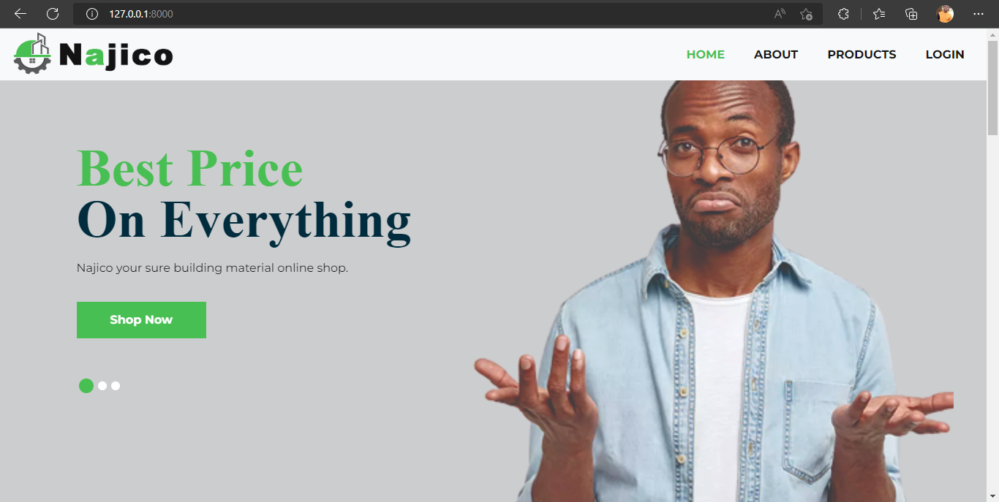

**Fig 4.6.1: Homepage**

**4.6.2 Customer Registration**

This is where the customer can register by providing his right credentials.

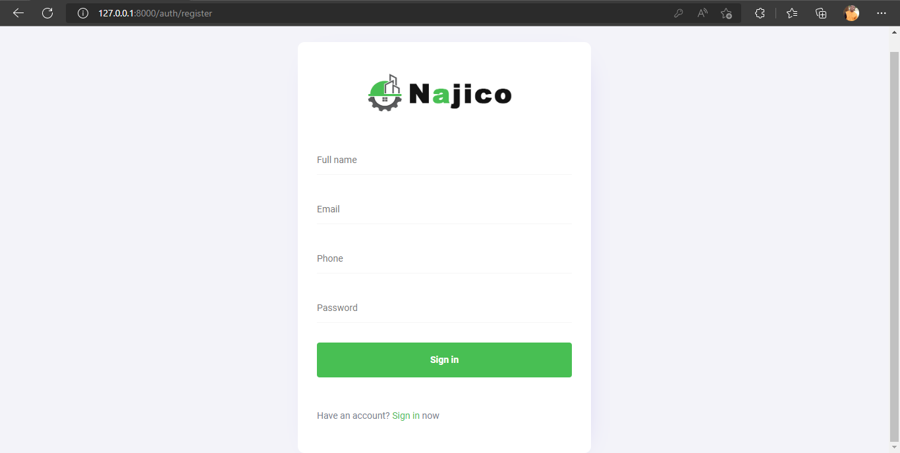

Fig 4.6.2: Customer Registration

**4.6.3 Customer Profile**

This is where the customer profile page where the customer can view, and change any of his or her profile information.

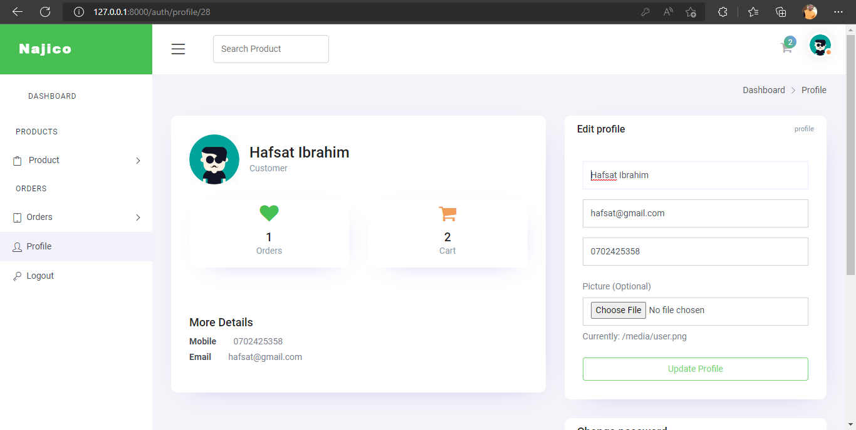

4.6.3 Customer Profile Page

**4.6.4 Add Building Materials**

This is where the admin can add new available building materials.

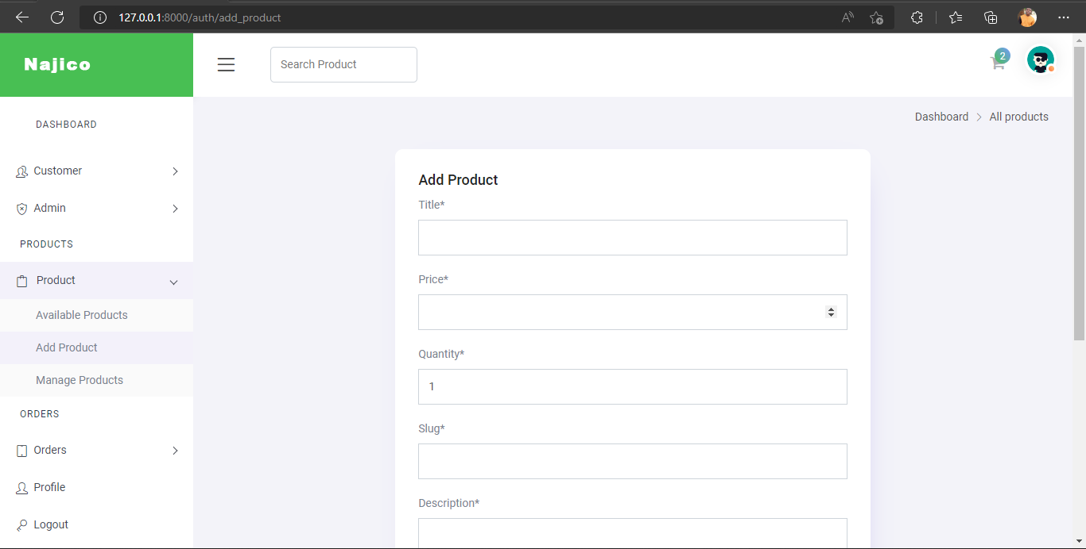

4.6.4 Add Building Materials

**4.6.5 Admin Dashboard**

This is the admin homepage where admin have access to his or her dashboard.

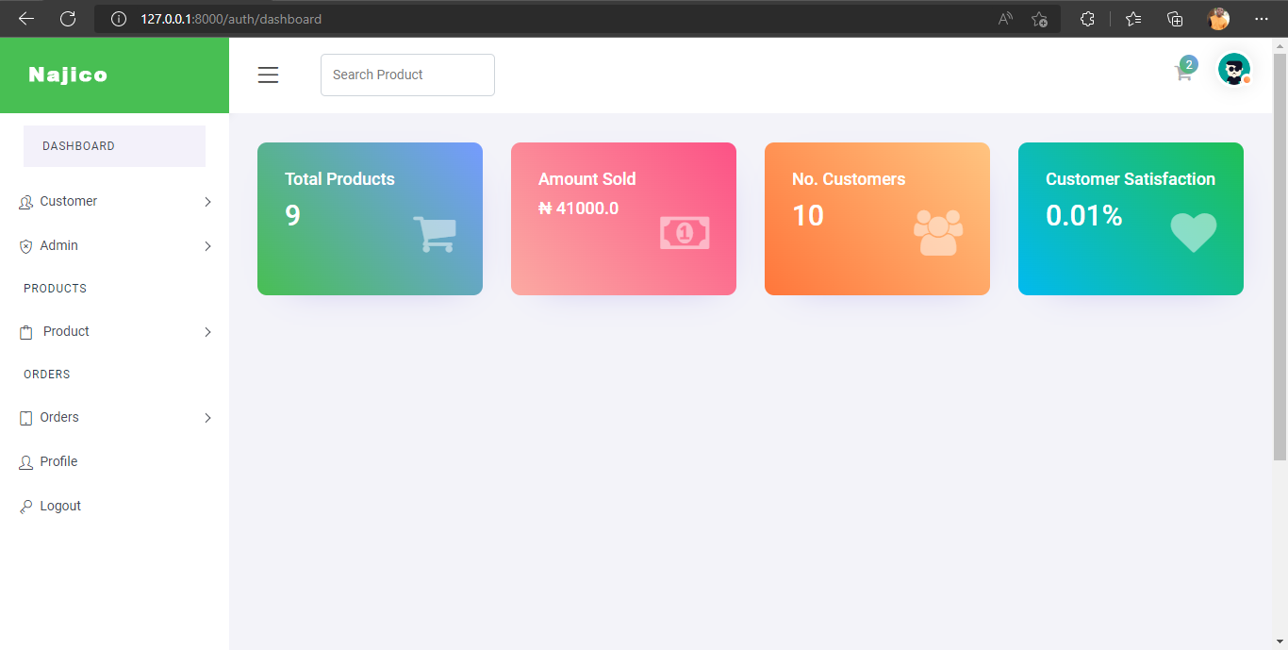

4.6.5 Customer Dashboard

**4.6.6 Customer Dashboard**

This is the customer homepage where customers have access to his or her dashboard.

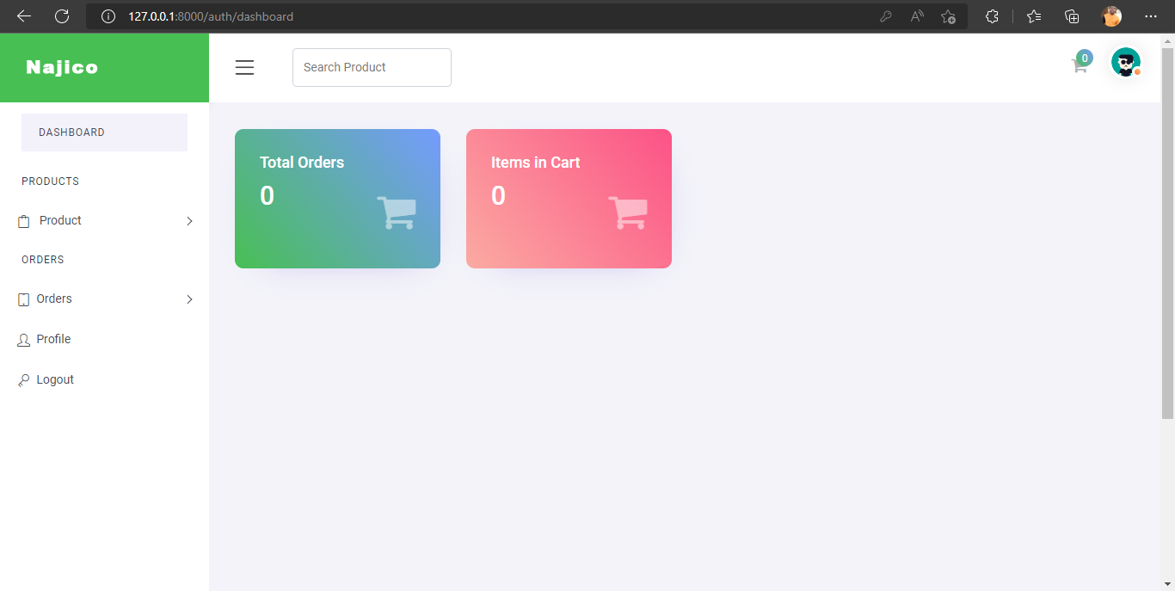

4.6.6 Customer Dashboard

**4.6.7 Available Building Materials**

This is the page where customers will have access to buy building materials

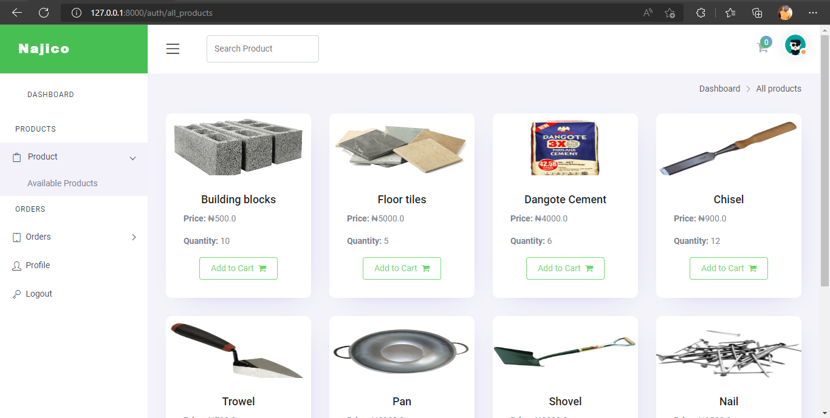

4.6.7 Available Building Materials

**4.6.8 Items in Cart**

This is when the customer can view the items in cart and decide to checkout

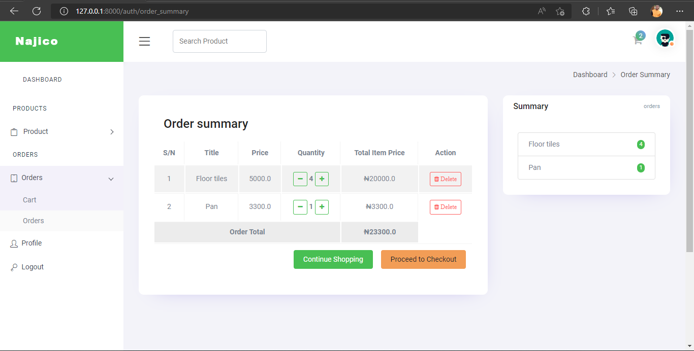

4.6.8 Items in Cart

**4.6.9 Payment Receipt**

This is the payment receipt received when customer have successfully made payment.

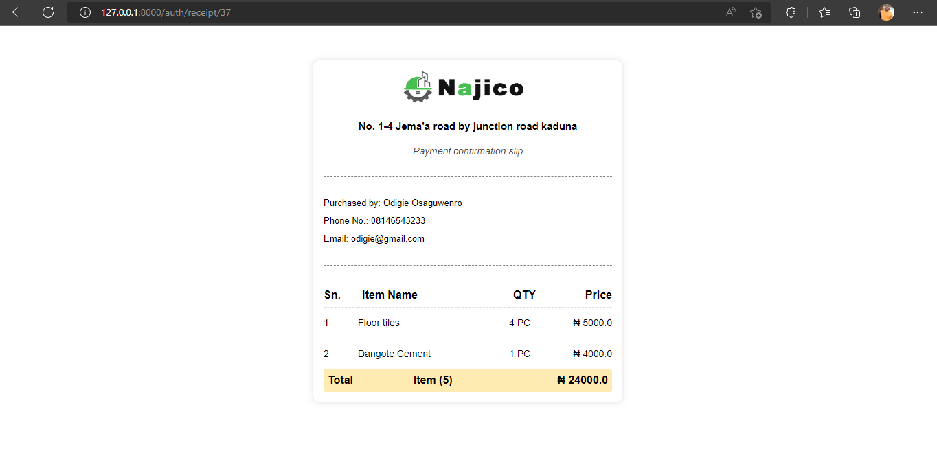

4.6.9 Payment Receipt

**4.6.9.1 Admin Manage Product**

This is the page where admin manages the available products.

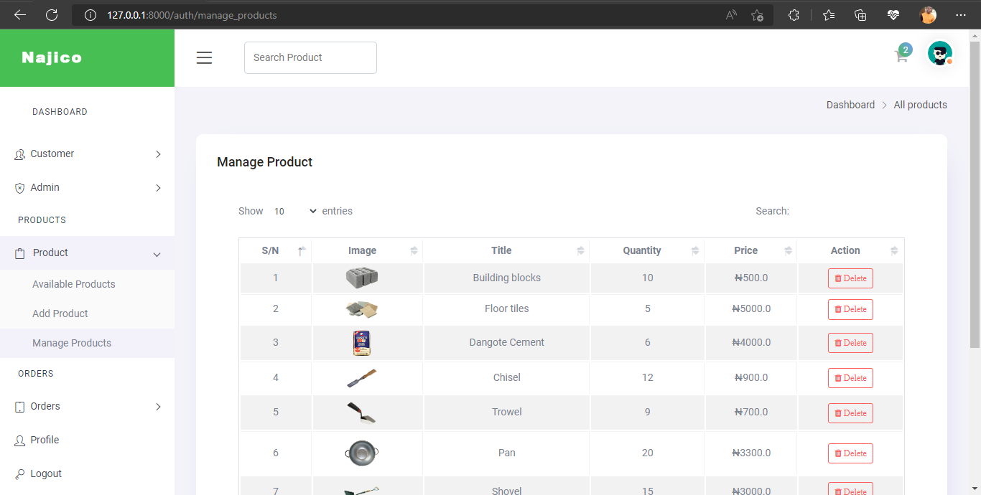

4.6.9.1 Admin Manage Product

**CHAPTER FIVE**

**SUMMARY, CONCLUSION AND RECOMMENDATION**

**5.1 Summary**

This project was design to solve a problem that exist in the manual booking and delivery of building materials and also serve as a replacement for the outdated manual system used in an organization. The project was a success and the set-out goals of the project was achieved and we were able to design a new system that can keep report/record and also print out payment invoice. The new features is to enhance the capacity of managing and record keeping of the activities of the organization and its staff.

**5.2 Conclusion**

The project was conducted successfully and the purposed of the new system was also achieved. The new system is an improvement compared with to the existing system. The new system is user friendly and it has new features that will be helpful to the organization

**5.3 Recommendation**

Afterward, the following suggestions are recommended:

* It is recommended that a mobile application should be developed in the near future.
* When the goods are ready the system should be able to alert the admin via SMS.
* Special backup system should be added to the system.

**5.4 Suggestion for further Studies**

The researcher after being limited to the scope of the study as a result of certain constraints therefore suggests to future researchers where inserts is on similar area recommended.

**REFERENCE**

s